Date of publication xxxx 00, 0000, date of current version xxxx 00, 0000.
Digital Object Identifier 10.1109/ACCESS.2024.Doi Number
Preparation of Papers for IEEE Access
(April 2024)
Bongu Lakshmi Sai Prasanna^{A}, Allam Neha Reddy^{A}, Yarlagadda Divya Sri^{A}, K.Swapnika^{A}
^{A}Department of Computer Science and Engineering, Koneru Lakshmaiah Education Foundation, Bowrampet, Hyderabad-500043, Telangana, India.
email-id: 2420030525@klh.edu.in
This paragraph of the first footnote will contain support information, including sponsor and financial support acknowledgment. For example,
“This work was supported in part by the U.S. Department of Commerce under Grant BS123456.”
ABSTRACT Business analytics helps companies make decisions by using lots of data. Machine learning is being used more and more for this because it can find patterns in data and predict what might happen next.. When the models are complicated it is hard to see why a prediction was made. This makes people less confident in the results and harder to know which factors matter most in a decision. In this study different machine learning methods are used along with Explainable Artificial Intelligence (XAI) tools in a business analytics setup. The research uses three known datasets, each linked to a different business area: the UCI Bank Marketing Dataset, the Telco Customer Churn Dataset and the UCI Online Retail Dataset. Before making the models the data is looked at. Prepared with steps like exploring the data cleaning it handling missing values removing duplicates finding outliers encoding data normalizing it doing feature engineering choosing the right features and splitting the data into training and test sets. Five machine learning methods – Logistic Regression, Decision Tree, Random Forest and XGBoost – are tested using measures like accuracy, precision, recall, F1-score ROC-AUC, confusion matrices and classification reports. To understand what the models are doing, SHAP, LIME, Partial Dependence Plots (PDP) Individual Conditional Expectation (ICE) and Permutation Feature Importance are used at both the individual levels. The models and their explanations are then compared based on how they perform how easy they are to understand how accurate the explanations are, how simple they are and how fast they run. The main goal is to find ML-XAI combinations that give clear information for real business decisions. Also a weighted hybrid model is looked at to see if combining methods can do better than using each one alone. Model selection and choosing the classification threshold are `done using validation data to make sure the test set is evaluated fairly. The study also looks at the balance between how the models predict and how easy they are to understand across the three business areas. The results are meant to help choose the machine learning and XAI methods, for making decisions based on data. Overall the research gives a way to compare how good the models are and how helpful their explanations are.
INDEX TERMS Explainable Artificial Intelligence; Business Analytics; Machine Learning; SHAP; LIME; Interpretability; Model Comparison; Feature Importance.
- INTRODUCTION
1. INTRODUCTION
1.1 Background
Business analytics consists of working with large quantities of data in order to assist organizations in making informed decisions. In recent years, machine learning has been applied to areas including customer churn, marketing response, customer behaviour, and transaction analysis. These models are able to produce predictions by detecting patterns in historical data, and the predictions thus obtained can be used to aid business decisions [7]- [9].
Even though complex machine learning models are able to give good predictive results, their decision-making process is usually hard for business users to grasp. A user might see the prediction but won't know which factors had an influence on it. This lack of clarity can reduce people's confidence in the model as well as harm its transparency and interpretability, and might in the end affect the quality of the decisions made on the basis of its output [18]–[20]. Explainable Artificial Intelligence (XAI) overcomes this problem by offering methods that enable users to investigate how a model behaves and to understand which features have contributed to its predictions [10], [11],[19].
1.2 Problem Statement
Machine learning algorithms can produce accurate predictions, but having those results make sense is not always guaranteed. Different tools and XAI approaches come with their own levels of prediction quality and how well they can be explained [18]- [20]. A lot of earlier work has focused on just one model, one XAI method, or a single kind of use case [19], [20].
Given this situation, having one shared setup where different machine learning algorithms and XAI methods can be tested across various business datasets becomes pretty helpful. That way both prediction quality and how well things can be explained can be looked at side by side [3]–[5], [19]. What this study really wants to find out is which pairing of machine learning algorithms and XAI techniques can deliver solid predictions while still offering understandable explanations, a reasonable use of computing power, and easier interpretability for business analytics.
1.3 Research Gap
Earlier research looked at XAI from different angles - things like model-agnostic explanation methods, how it's used in finance, classification systems, and ways to judge explanations [1]-[6]. But a few problems are still waiting to be solved. For instance, how do we measure if explanations are good and consistent? How understandable are they? What kind of computing power do they need? And do these explanations actually help people who use them [8], [10], [19]? Studies also mention a give-and-take between how well a model predicts and how easy it is to understand, especially when you're dealing with complex black-box models [13], [17]. Because of these shortcomings, we really need a shared comparison framework that can evaluate many machine learning models and XAI methods across various business analytics datasets. Most current studies look at each machine learning model on its own instead of asking whether combining complementary models (like ensembles) could give better predictions while still keeping things explainable. In particular, there's a need for a method that brings together different tree-based learning approaches, fine-tunes their input with validation data, and then explains what the combined predictions mean [10], [11]. This study fills that gap by building a hybrid ensemble - one that mixes Random Forest and HistGradientBoosting with weighted soft voting and classification-threshold optimization [3]–[5], [21]. After that, it uses SHAP and LIME to explain the results.
1.4 Research Objectives
1.To build machine learning models that study and forecast results when working with business datasets.
2. To apply SHAP, LIME, PDP, ICE, and Permutation Feature Importance to clarify what each model's predictions mean.
3. To compare how well Logistic Regression, Decision Tree, Random Forest, XGBoost, and HistGradientBoosting actually predict things.
4. To compare how explainable different ML-XAI pairings are looking at things like clarity, how true they stay to the model, fidelity, sparsity, and how fast they run.
5.To evaluate the proposed hybrid model along with XAI methods by checking its prediction performance, how faithful its explanations are, how easy they are to understand, and how efficient they are to compute. Based on that, suggest which machine learning and XAI combos work best for making business analytics decisions.
1.5 Research Questions
• RQ1: How do Logistic Regression, Decision Tree, Random Forest, XGBoost and HistGradientBoosting perform differently when it comes to predicting outcomes across datasets used in business analytics?
• RQ2: Which explainable AI techniques offer the most helpful global and local explanations for the machine learning models that are being studied?
• RQ3: How do factors like explanation fidelity, sparsity, interpretability and computational efficiency change when different machine learning models are paired with explainable AI methods?
• RQ4: Which combination of machine learning model and explainable AI approach provides the best trade-off between accurate predictions and clear understandable explanations, for business decisions?
1.6 Contributions
• A single system for looking at machine learning models and XAI methods on standard business data sets.
• A step by step way to pick the mix of models and the right point to make decisions using data that is not used for testing.
• A direct look at how each model predicts and how easy it is to understand what the model is doing.
• Using SHAP and LIME to explain what the models are doing both overall and for cases.
• Measures that show how accurate the explanations are and how easy they are to understand.
• A check, on combinations of machine learning and XAI methods.
1.7 Organization of the Paper
Section 2 looks at earlier studies on machine learning and Explainable Artificial Intelligence. In Section 3, we go over the study's methods - things like the datasets, how data was prepped, the machine learning models, and XAI approaches. Section 4 covers how the experiments were set up and which evaluation metrics were chosen. Section 5 shows the findings and compares different models and methods. Section 6 digs into what these results actually mean in practice. Section 7 points out the study’s limits. And Section 8 wraps everything up with a conclusion and suggests some possible directions for future research.
2. RELATED WORK
2.1 Earlier work in machine learning placed a lot of weight on how good a model was at guessing an outcome. Tools like Logistic Regression, Decision Trees, and ensemble methods get used a lot for sorting and predicting things. Simple models tend to be easier for people to wrap their heads around. On the other hand, fancier models can notice tricky patterns in data but are much harder to make sense of [18]–[20].This gap between making predictions and actually understanding what is going on pushed researchers to create Explainable Artificial Intelligence, or XAI for short. XAI brings together a bunch of methods that help people see how a model reaches its conclusions. It also shows which pieces of information mattered most for a given guess [10], [11], [19].
2.2 Machine Learning / Computational Approaches
When people use machine learning for business analytics, they often turn to Logistic Regression, Decision Trees, Random Forest, and XGBoost. Logistic Regression is pretty simple to understand, so it works well as a starting point for comparison. Decision Trees lay out their choices in a tree-like shape, which makes the results fairly easy to follow. Random Forest combines multiple decision trees to improve predictive robustness and generalization [1], [4]. XGBoost uses a scalable gradient-boosting framework for predictive modeling [7].
2.3 Advanced / Alternative Approaches
Methods that help explain models fall into two groups: those that work with any model and those that only work with specific ones. LIME looks at one guess at a time by building a simpler picture of what the model does near that guess [11]. SHAP uses something called Shapley values to point out how much each piece of data helped shape the guess. It can explain both single guesses and the overall pattern [10].Partial Dependence Plots (PDP) show what happens to predictions when you change one of the input values [2]. Individual Conditional Expectation (ICE) plots take this further by showing how predictions shift for each separate data point [14]. Permutation Feature Importance checks how much a feature matters by randomly mixing up its values and seeing how much the model's accuracy drops [15], [16].
2.4 Explainability / Interpretability
Accurate predictions are key in business analytics. They may not be enough when people must decide based on those predictions. People also need to know why the model gave a result. XAI methods help by giving users a view of how the model works and what influences its predictions [10], [11], [18]–[20].SHAP and LIME can be used to understand predictions at both the global level [11] [12] [25]. PDP, ICE and feature-importance methods give ways to see how features influence predictions [2], [14]–[16].Previous studies have also highlighted problems in measuring the quality and consistency of explanations the cost and the usefulness of these explanations to users [18]–[20]. Because of these problems our framework looks at explainability, with predictive performance instead of treating explainability as a separate part of evaluation.
2.5 Critical Comparison

# | Study / Publication | Key Contribution | Limitation
1 | Model-Agnostic Explainable Artificial Intelligence Methods in Finance: A Systematic Review (2025)[1] | Reviews SHAP, LIME, PDP, counterfactuals and other model-agnostic XAI techniques. | Lacks extensive real-world validation of XAI methods on different financial datasets.
2 | A Comprehensive Review on Financial Explainable AI (2025)[2] | Reviews XAI techniques, applications and challenges in financial decision-making. | Does not propose a unified framework for improving financial XAI.
3 | XAI: Survey of Needs, Techniques, Applications & Future Direction (2024)[3] | Gives a broad overview of XAI methods, applications, requirements, and future directions. | Lacks standardized metrics for evaluating explanation quality.
4 |  | Reviews XAI applications in finance and the challenges in evaluating explanations. | Does not fully resolve the trade-off between accuracy and interpretability.
  XAI in Finance: A Systematic Literature Review (2024)[4]
5 | A Comprehensive Taxonomy for Explainable Artificial Intelligence: A Systematic Survey of Surveys on Methods and Concepts (2023/24)[5] | Gives a taxonomy for classifying XAI methods and concepts. | Lacks practical implementation and evaluation of the classified XAI methods.
6. |  | Reviews black-box interpretation techniques and discusses their strengths and limitations. | Gives limited guidance on choosing the best explanation method for different applications.
  Interpreting Black-Box Models: A Review on XAI (2024) [6]
7. | Transformative Impact of XAI: Bridging Complexity and Trust (2025) [7] | Reviews model-specific, model-agnostic and hybrid XAI approaches and discusses accuracy–interpretability trade-offs. | Further practical validation is needed to determine how XAI improves user trust in real-world systems.
8. | Review of Evaluation Approaches for XAI (2024) [8] | Examines XAI evaluation approaches and finds little systematic evaluation. | No universally accepted framework exists for evaluating explanation quality.
9. | Privacy-Preserving XAI: A Survey (2024/25) [9] | Reviews XAI methods while addressing privacy-related challenges. | Maintaining privacy while providing detailed and useful explanations remains challenging.
10. |  | Reviews factors affecting explanation usefulness, usability and user trust. | More empirical studies are required to validate user-centered XAI guidelines across different domains.
  User-Centered XAI Design Guidelines: Systematic Literature Review (2025) [10]
Table 1. Comparison of representative studies on Explainable Artificial Intelligence, with what each contributes and where it falls short.
2.6 Research Gap (Summary) The existing research shows that XAI methods are different, in terms of their purpose the way they create explanations how those explanations are checked and the areas where they can be applied [10], [11], [19], [20].Many past studies look at one method or one area of use rather than comparing different machine learning models across several business [3]–[5], [19], [20].In this study we compare ML. XAI methods using predictive performance, fidelity, sparsity, interpretability and computational effectiveness as the main evaluation factors.
3. PROPOSED METHODOLOGY
3.1 Overall Framework
The study starts by gathering the benchmark datasets.
The proposed framework has five stages: data preparation, baseline model development, hybrid model construction and optimization independent test evaluation and explainability analysis.
First the benchmark datasets are gathered, cleaned, analyzed and changed into a feature representation. The processed datasets are split into training, validation and test subsets.
In the stage individual machine learning models are trained to set baseline predictive performance [1], [2], [7]. Random Forest and HistGradientBoosting are then chosen as the component models, for the proposed hybrid ensemble.
In the stage the two component models are joined using weighted soft voting [3]–[5]. Different combinations of weights and classification thresholds are tested using the validation dataset. The setup that gives the validation F1-score is chosen as the final hybrid setup [21], [26].
In the stage the chosen hybrid model is tested on the independent test dataset. The test dataset is not used when setting weights or thresholds.
Finally SHAP and LIME are used to explain the predictions of the chosen model. The explanations that result are checked using fidelity and sparsity measures [10], [11], [19] to give both interpretability analysis.
3.2 Dataset(s)
- UCI Bank Marketing Dataset: Used to represent banking and marketing analytics.[31]
- Telco Customer Churn Dataset: Used to represent customer analytics and churn prediction[32]
- UCI Online Retail Dataset: Used to represent e-commerce and customer transaction analytics.[30]

3.3 Data Preprocessing
The following preprocessing steps are proposed:
• Data cleaning
• Missing-value handling
• Duplicate record removal
• Outlier detection and treatment
• Categorical data encoding
• Feature scaling or normalization
• Feature engineering
• Feature selection
• Train-test splitting
All of these steps are part of the project pipeline.

3.4 [ Exploratory Analysis / Feature Engineering, as relevant]
Exploratory Data Analysis is used to understand the structure and quality of each dataset before building the models. It involves checking the dataset overview looking at statistics identifying missing values finding duplicate records and detecting outliers. The data is also examined using analysis, bivariate analysis, multivariate analysis and correlation analysis. After this feature engineering and feature selection are done to prepare the features for model development. Different visualizations, like heatmaps, boxplots, correlation matrices and feature importance graphs are used to understand the data and the features clearly.

3.5 Proposed Model(s) and Baselines
•First examine each machine learning model to set a baseline for performance. The baseline models are Logistic Regression, Decision Tree, Random Forest, XGBoost and HistGradientBoosting [1], [2], [7], [9]. These models cover methods, tree methods, bagging methods and boosting methods.
•After the baseline test merge Random Forest and HistGradientBoosting to build the proposed hybrid model. Random Forest supplies separate decision trees that vote together. HistGradientBoosting uses gradient boosting to capture nonlinear patterns. Together they give predictive [3]–[5].

• Then we label the model a validation-optimized weighted RF–HGB soft-voting ensemble. Then picking the prediction of one classifier the model blends the probability scores from Random Forest and HistGradientBoosting.
•Then fine‑tune the weights and the classification threshold with the validation data. I test 867 weight–threshold pairs. I pick the pair that gives the F1‑score on the validation set [21], [26]. The test data stays completely separate from this tuning.
•On the Online Retail data the chosen hybrid uses a weight of 0.30 for Random Forest and 0.70 for HistGradientBoosting.
•After the predictions we use SHAP and LIME to explain both the model and individual decisions. This way my method brings together learning, validation tuning and explainable artificial intelligence, in one package.

Explainability Techniques
SHAP shows how much each feature contributes to model predictions [10]. LIME gives explanations for single model predictions [11]. Partial Dependence Plots show how predictor variables relate to model predictions [2]. Individual Conditional Expectation plots display prediction behavior for instances [14]. Permutation Feature Importance estimates how important each feature is by looking at changes in model performance[14].
3.6 Algorithmic / Mathematical Formulation
For classification evaluation, the following measures are considered:

Hybrid Ensemble Formulation
The proposed hybrid model combines the probability outputs of Random Forest and HistGradientBoosting using weighted soft voting [3]–[5]:
For the Online Retail model:
Accuracy:
Accuracy = (TP + TN) / (TP + TN + FP + FN)
Precision:
Precision = TP / (TP + FP)
Recall:
Recall = TP / (TP + FN)
F1-Score:
F1 = 2 × (Precision × Recall) / (Precision + Recall)
Here, TP represents true positives, TN represents true negatives, FP represents false positives, and FN represents false negatives [22]–[24].
Explainability Evaluation
To evaluate the SHAP and LIME explanations two measures are considered: Fidelity and Sparsity.
Fidelity
Fidelity measures how closely an explanation follows the prediction behavior of the machine learning model. A higher fidelity value means that the explanation matches the models behavior closely.
In this study fidelity is used to assess the SHAP and LIME explanations for the Bank Marketing, Online Retail and Telco Customer Churn datasets. It provides a way to evaluate explanation quality rather than relying only on visual inspection of feature-importance plots [10], [11], [19].
Sparsity
Sparsity describes how compact an explanation is by looking at the number of features used to explain a prediction. An explanation that uses features is generally easier for a business user to understand. Therefore sparsity helps show whether a prediction can be explained using a small number of important features. In this study sparsity is used to examine the complexity of the SHAP and LIME explanations. It shows whether the explanation focuses on a list of influential features while still providing useful information about the prediction.
Sparsity measure two different aspects of an explanation. Fidelity indicates how closely the explanation represents the model while sparsity indicates how simple and compact the explanation is. [11], [19].
4. EXPERIMENTAL SETUP
4.1 Hardware and Software
The implementation is done using Python. A number of libraries that are often used for data analytics, machine learning and visualization. The main libraries used in the project are:
- Python
- Pandas
- NumPy
- Scikit-learn
- XGBoost
- SHAP
- LIME
- Matplotlib
- Seaborn
This project uses open-source tools and available datasets. This makes the project practical, from both a perspective and a cost perspective.
4.2 Dataset Split / Design
After preprocessing and feature engineering every dataset is split into training, validation and test parts. The training part is used to train the machine learning models. The validation part is used to adjust the weights and the classification threshold of the RF–HGB hybrid model that we developed. The test part is used for the final check of the model that we chose. This split makes sure that the test data does not affect the choices made during model selection and gives an idea of how well the final hybrid model works [25], [26].
4.3 Hyperparameter Configuration
Each baseline machine learning model is set up with model parameters for the specific classification task. For the proposed hybrid model the key optimization parameters are the weights given to Random Forest and HistGradientBoosting as well as the classification threshold used on the combined probability output [21], [26].
4.4 Validation Strategy
We use a validation dataset to choose the best configuration for the hybrid model. The validation process looks at different combinations of Random Forest and HistGradientBoosting ensemble weights and classification thresholds.
During the optimization procedure we evaluate a total of 867 configurations. The configuration that gives the highest validation F1-score becomes the hybrid configuration. We do not use the test dataset during this optimization. Once the hybrid model configuration is fixed we run the hybrid model once on the independent test dataset [21], [25], [26].
4.5 Evaluation Metrics
• Accuracy: Accuracy tells us how many instances were classified correctly.
• Precision: Precision tells us how many of the instances that we predicted as positive are truly positive.
• Recall: Recall tells us how many of the positive instances we found.
• F1-Score: The F1-score is a number that balances precision and recall.
• ROC-AUC: ROC-AUC shows how well the model can separate the two classes.
•Confusion Matrix: The confusion matrix gives a breakdown of which instances were classified correctly and which were not.
•Classification Report: The classification report shows performance metrics, for each class separately [22]–[24].
4.6 Statistical Testing
The project proposes comparative evaluation of model performance and explainability.
5. RESULTS
5.1 Overall Performance
The experimental analysis compares Logistic Regression, Decision Tree, Random Forest and XGBoost using the selected business datasets. The comparison focuses on how each model performs in prediction and how easy each model is to interpret and explain [18]–[20]
5.2 Model / Method Comparison
The individual baseline models are compared with the proposed RF–HGB model using accuracy, precision, recall, F1-score and ROC-AUC. The Online Retail results are shown below.
The proposed hybrid produces the F1-score among the reported models with a value of 0.961829. Compared with HistGradientBoosting the proposed hybrid improves F1-score from 0.960082 to 0.961829 [22], [23].

However the hybrid ROC-AUC of 0.818351 is slightly lower than the HistGradientBoosting ROC-AUC of 0.823543.
Therefore the hybrid should be interpreted as an improvement for the selected F1-based decision objective than, as a model that outperforms the individual baseline on every metric.
Method | Accuracy | Precision | Recall | F1-score | RO-AUC
Logistic Regression | 0.542724 | 0.933015 | 0.539655 | 0.683800 | 0.580572
Decision Tree | 0.593068 | 0.954958 | 0.583374 | 0.724288 | 0.694895
Random Forest | 0.665211 | 0.965428 | 0.658166 | 0.782723 | 0.775211
XGBoost | 0.920422 | 0.920161 | 0.999903 | 0.958376 | 0.742217
HistGradientBoosting | 0.923834 | 0.923478 | 0.999708 | 0.960082 | 0.823543
Proposed RF–HGB Hybrid | 0.927730 | 0.931873 | 0.993774 | 0.961829 | 0.818351
Table 2. Comparative performance of machine learning models on the selected business analytics datasets.

5.3 [ Additional Result Sub-section, e.g., Error/Confusion Analysis]
The confusion matrix for the RF–HGB hybrid model is used to look at the classification errors on the independent Online Retail test set.
The matrix shows 1,352 negatives, 5,228 false positives, 448 false negatives and 71,511 true positives. The high recall of 0.993774 shows that the hybrid model finds the majority of repeat customers. Because the Online Retail target is strongly imbalanced toward the repeat-customer class, F1-score, precision, recall and ROC-AUC give useful information than accuracy alone [22]–[24].
5.4 [ Additional Result Sub-section, e.g., Feature/Factor Importance]
Feature importance graphs, SHAP visualizations, LIME visualizations, PDP, ICE and Permutation Feature Importance are used to find the factors that influence the models predictions. The explanations created by these methods are compared to examine differences between global feature importance and local interpretability. SHAP provides feature-attribution explanations [10], LIME explains individual predictions [11], PDP illustrates the relationship between predictors and model outputs [2], ICE displays instance-level prediction effects [14], and permutation feature importance evaluates the effect of disrupting feature values on model performance [15], [16].
6. DISCUSSION
6.1 Interpretation of Findings
The experimental results show that combining Random Forest and HistGradientBoosting through weighted voting can give a small boost in F1-score compared with the strongest single baseline [3]–[5]. The final hybrid model uses a Random Forest weight of 0.30 and a HistGradientBoosting weight of 0.70 along with a classification threshold of 0.64. The hybrid model achieved a test F1-score of 0.961829 compared to 0.960082 for HistGradientBoosting. This shows an improvement in the balance between precision and recall. The hybrid model also reached an accuracy of 0.927730, precision of 0.931873 and recall of 0.993774. However the models ROC-AUC of 0.818351 was slightly lower than the HistGradientBoosting ROC-AUC of 0.823543. This result suggests that the benefit of the hybrid model comes from the tuned classification objective and decision threshold rather than a uniform rise in all performance metrics [21]. The use of SHAP and LIME gives interpretability for the hybrid model letting us see the key factors that drive predictions, from both a global and a local viewpoint [10], [11].
6.2 Comparison With Previous Studies
Previous studies have pointed out challenges, such as how to evaluate explanations the trade-off between accuracy and interpretability the consistency of explanations the computational cost and how easily users can understand explanations [18]–[20]]. This study tackles these challenges by putting evaluation factors together in one single framework, for comparison.
6.3 Theoretical Implications
The proposed approach shows that ensemble learning and explainability can work together in a predictive system. Of using just one learning method the RF–HGB hybrid brings together bagging-based and boosting-based strategies by combining their predictions using weighted probabilities [3]–[5]. Validation-based optimization helps to find out how much each model contributes and sets the right classification threshold [21], [26].
The results also show that better performance in one measurement doesn’t always mean performance, in others. Because of this it’s important to test hybrid models using performance measures. This way we can get a picture of how predictive performance connects with interpretability [19], [20].
6.4 Practical Implications
The proposed RF–HGB hybrid is well suited for business analytics applications where both accurate classification and clear interpretable predictions matter [18]–[20]. By using a validation-optimized weighting method the system is able to blend the strengths of two tree-based models instead of relying on just one classifier.
In the Online Retail use case the model shows recall and F1-score meaning it performs well in detecting repeat-customer behavior. This is important because identifying customers who are likely to return helps businesses plan marketing and retention strategies.
To make sense of the model’s decisions SHAP and LIME explanations can be applied. These tools help reveal which features influence each prediction and show how the model behaves overall. This transparency allows business users to trust the model’s outputs and use them confidently when making decisions, about customer engagement, promotions or service improvements [26].
6.5 Unexpected Findings
If there are any differences, between the models and the XAI techniques I will record them based on the results that come from the experiments.
7. LIMITATIONS
1. The study focuses on the benchmark business datasets that were chosen.
2. The way well XAI techniques work can be different depending on the machine learning model and the data used.
3. It is hard to measure how good and easy to understand the explanations are with one single measure.
4. The amount of computing power needed can change from one machine learning method to another and from one XAI technique to the next.
5. Business users may not all understand the explanations, in the way.
8. CONCLUSION AND FUTURE WORK
This research offers an approach to compare machine learning models and Explainable Artificial Intelligence methods in business analytics. It looks at machine learning models and introduces a hybrid ensemble called RF–HGB, which combines Random Forest and HistGradientBoosting. The model uses weighted voting and optimizes the classification threshold for better performance [3]–[5].
The hybrid model is tuned using validation data while the test dataset stays untouched to ensure an evaluation. On the Online Retail dataset the best setup assigns 0.30 weight to Random Forest and 0.70 to HistGradientBoosting with a classification threshold set at 0.64. The final results on the test set show an accuracy of 0.927730, precision of 0.931873, recall of 0.993774, F1-score of 0.961829 and ROC-AUC of 0.818351.
While the hybrid model improves the F1-score compared to the HistGradientBoosting baseline it does not beat the baseline across all metrics. SHAP and LIME are used to provide both local explanations of predictions helping understand how decisions are made. Together the performance evaluation and explanation analysis give a picture of the model’s usefulness, in real-world business settings. This work brings together learning, optimization based on validation data and explainable AI into one cohesive framework [10], [11].
Future Work
1. Expand the framework to include business datasets and different areas where it can be used.
2. Add XAI methods and ways to measure how good the explanations are.
3.Do thorough statistical checks to see how models and explanations differ.
4.Make the interactive dashboard better so business uses evaluate and make decisions easily.
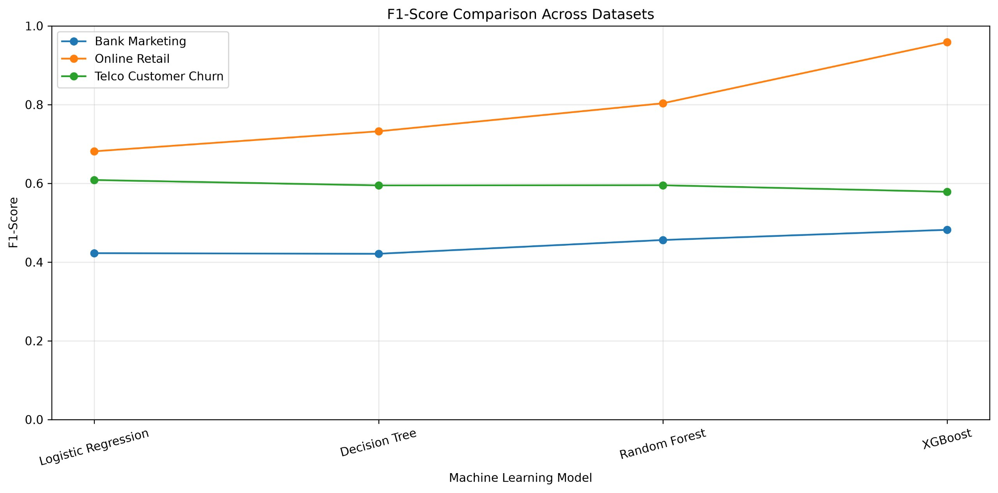
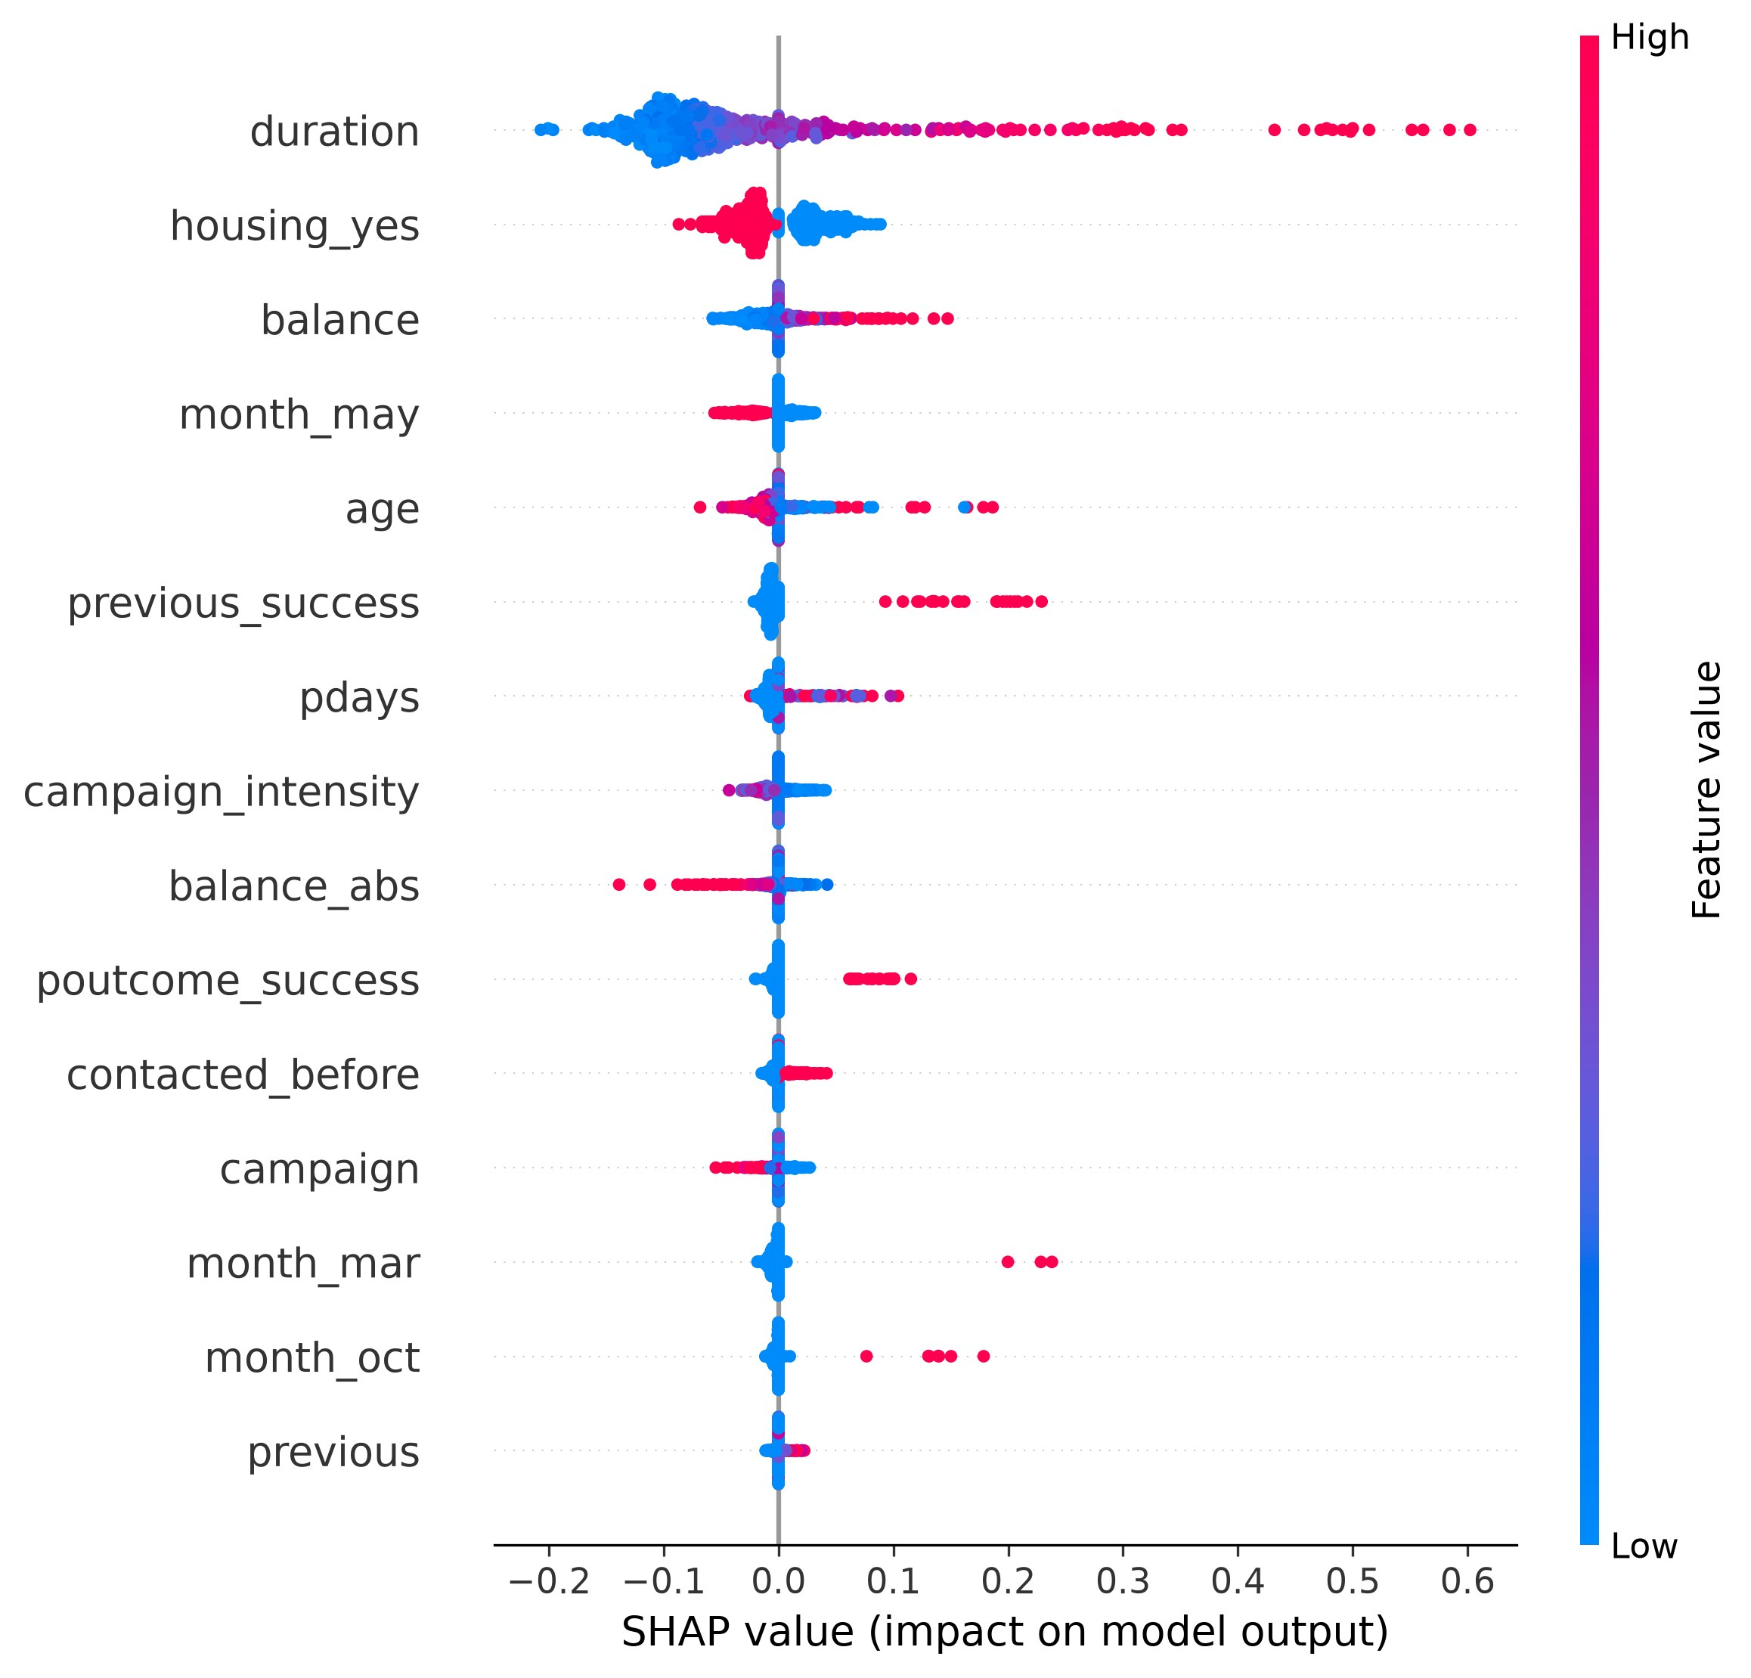
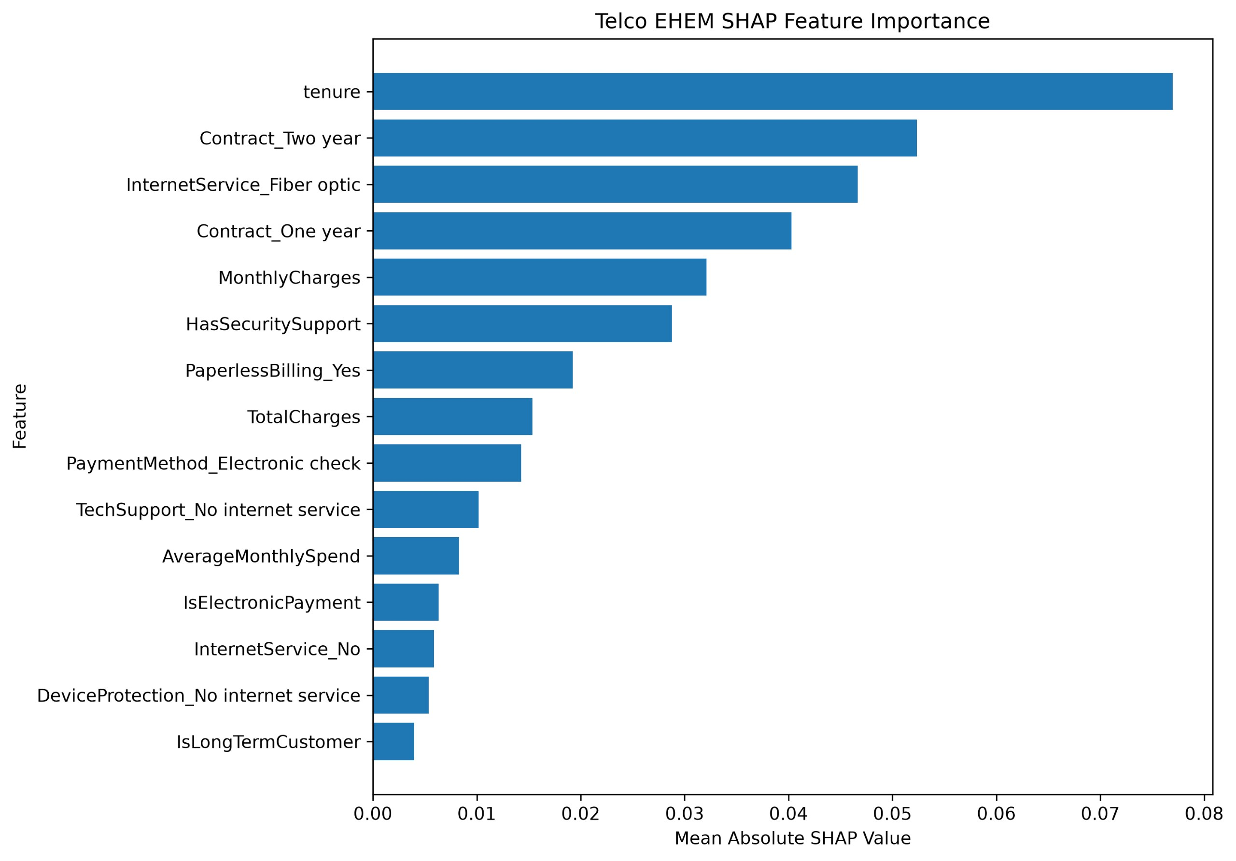
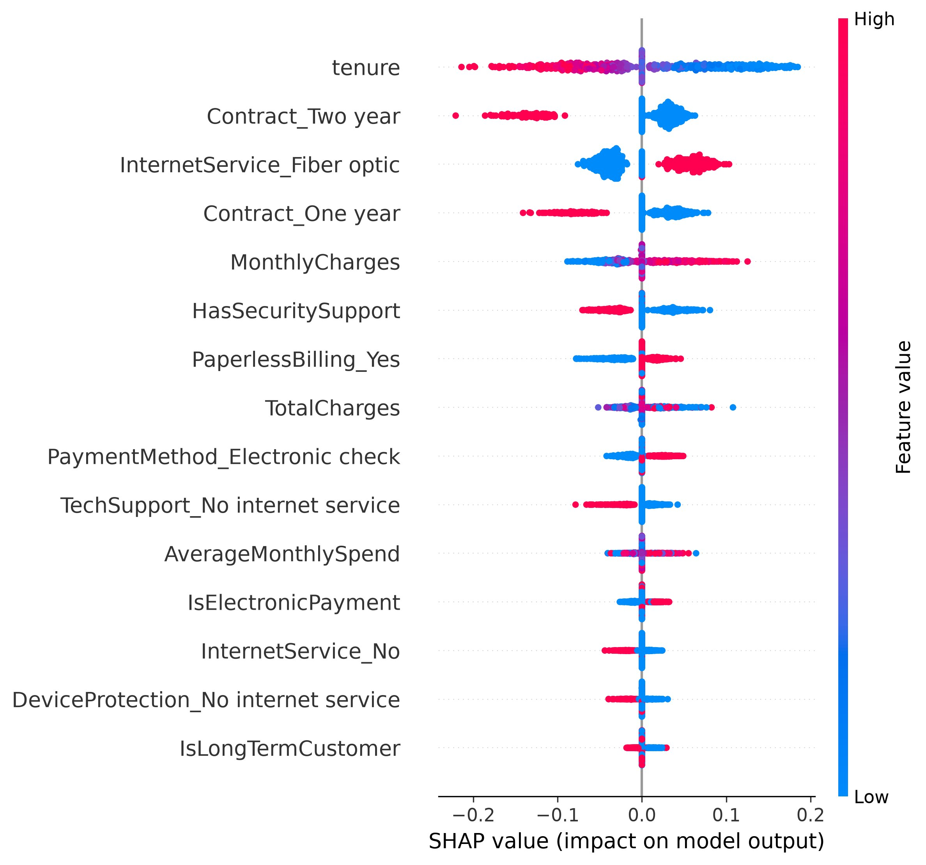
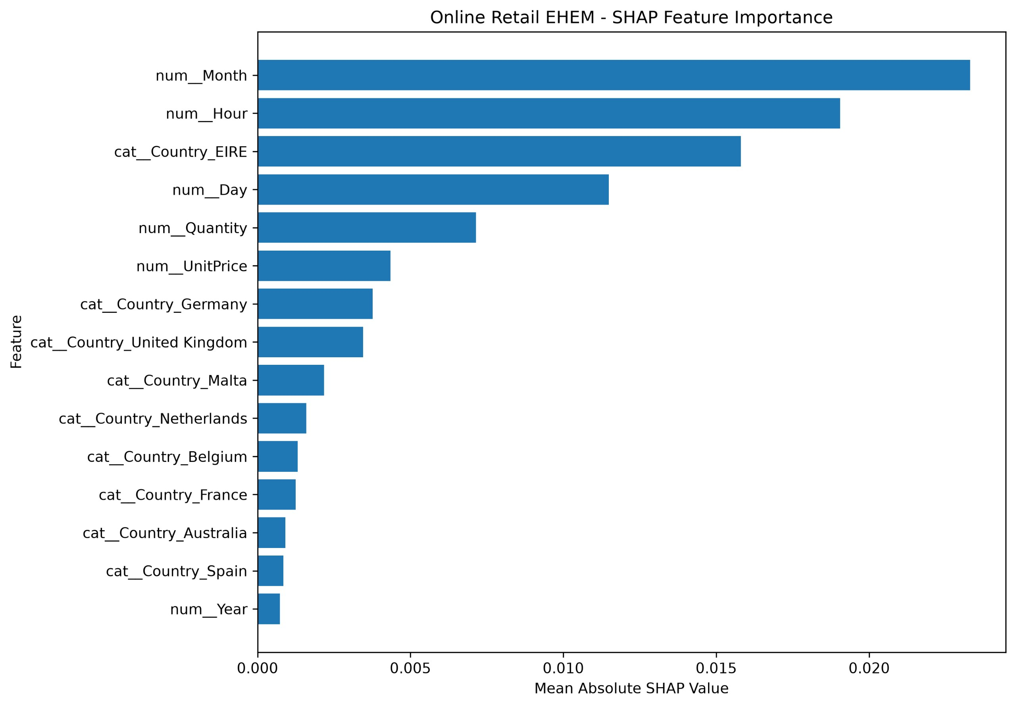
DECLARATIONS
Funding
No external funding was reported for the project.
Conflict of Interest
The authors declare no conflict of interest, subject to confirmation by all listed authors.
Ethics Statement
The proposed study uses available business datasets, including the UCI Bank Marketing dataset, the Telco Customer Churn dataset and the UCI Online Retail dataset to evaluate machine learning models and Explainable Artificial Intelligence (XAI) techniques for business analytics. No new data were collected directly from participants and no experiments involving human subjects or animals were conducted. The study relies on secondary data analysis and appropriate measures are taken to use the datasets responsibly and protect any information contained in the source data. Institutional ethics approval was not sought because the study did not involve human-subject recruitment or intervention subject, to the applicable institutional guidelines.
Data Availability
The datasets that were used in this study, including the UCI Bank Marketing dataset, the Telco Customer Churn dataset and the UCI Online Retail dataset can be found online. These datasets are available, from the places where they were first shared. The information can be found by going to the UCI Machine Learning Repository and other places where data is stored. The code that was used for preparing the data building the machine learning models and doing the AI analysis will be shared when asked for or put in an open place but only after it is checked one last time.
Author Contributions
Bongu Lakshmi Sai Prasanna: XAI implementation, comparative analysis, visualization, Dataset analysis, machine learning implementation, evaluation and documentation. Additional author contributions: Allam Neha Reddy, Yarlagadda Divya Sri, K Swapnika.
Acknowledgements
The authors acknowledge the project supervisor, department and data/API providers where applicable. Specific names and provider acknowledgements should be inserted after verification.

REFERENCES
1. Breiman, L. (2001). Random Forests. Machine Learning, 45, 5–32. https://doi.org/10.1023/A:1010933404324
2. Friedman, J. H. (2001). Greedy Function Approximation: A Gradient Boosting Machine. The Annals of Statistics, 29(5), 1189–1232. https://doi.org/10.1214/aos/1013203451
3. Dietterich, T. G. (2000). Ensemble Methods in Machine Learning. Multiple Classifier Systems, 1–15. https://doi.org/10.1007/3-540-45014-9_1
4. Breiman, L. (1996). Bagging Predictors. Machine Learning, 24, 123–140. https://doi.org/10.1007/BF00058655
5. Wolpert, D. H. (1992). Stacked Generalization. Neural Networks, 5(2), 241–259. https://doi.org/10.1016/S0893-6080(05)80023-1
6. Ke, G., et al. (2017). LightGBM: A Highly Efficient Gradient Boosting Decision Tree. Advances in Neural Information Processing Systems 30. https://proceedings.neurips.cc/paper/2017/hash/6449f44a102fde848669bdd9eb6b76fa-Abstract.html
7. Chen, T., and Guestrin, C. (2016). XGBoost: A Scalable Tree Boosting System. Proceedings of the 22nd ACM SIGKDD International Conference on Knowledge Discovery and Data Mining. https://doi.org/10.1145/2939672.2939785
8. Hastie, T., Tibshirani, R., and Friedman, J. (2009). The Elements of Statistical Learning: Data Mining, Inference, and Prediction (2nd ed.). Springer. https://doi.org/10.1007/978-0-387-84858-7
9. Friedman, J. H. (2002). Stochastic Gradient Boosting. Computational Statistics & Data Analysis, 38(4), 367–378. https://doi.org/10.1016/S0167-9473(01)00065-2
10. Lundberg, S. M., and Lee, S.-I. (2017). A Unified Approach to Interpreting Model Predictions. Advances in Neural Information Processing Systems 30. https://proceedings.neurips.cc/paper/2017/hash/8a20a8621978632d76c43dfd28b67767-Abstract.html
11. Ribeiro, M. T., Singh, S., and Guestrin, C. (2016). “Why Should I Trust You?”: Explaining the Predictions of Any Classifier. Proceedings of the 22nd ACM SIGKDD International Conference on Knowledge Discovery and Data Mining, 1135–1144. https://doi.org/10.1145/2939672.2939778
12. Molnar, C. (2022). Interpretable Machine Learning (2nd ed.). https://christophm.github.io/interpretable-ml-book/
13. Apley, D. W., and Zhu, J. (2020). Visualizing the Effects of Predictor Variables in Black Box Supervised Learning Models. Journal of the Royal Statistical Society: Series B, 82(4), 1059–1086. https://doi.org/10.1111/rssb.12377
14. Goldstein, A., Kapelner, A., Bleich, J., and Pitkin, E. (2015). Peeking Inside the Black Box: Visualizing Statistical Learning with Plots of Individual Conditional Expectation. Journal of Computational and Graphical Statistics, 24(1), 44–65. https://doi.org/10.1080/10618600.2014.907095
15. Fisher, A., Rudin, C., and Dominici, F. (2019). All Models Are Wrong, but Many Are Useful: Learning a Variable’s Importance by Studying an Entire Class of Prediction Models Simultaneously. Journal of Machine Learning Research, 20(177), 1–81. https://www.jmlr.org/papers/v20/18-760.html
16. Hooker, G., and Mentch, L. (2019). Please Stop Permuting Features: An Explanation and Alternatives. https://arxiv.org/abs/1905.03151
17. Doshi-Velez, F., and Kim, B. (2017). Towards a Rigorous Science of Interpretable Machine Learning. https://arxiv.org/abs/1702.08608
18. Rudin, C. (2019). Stop Explaining Black Box Machine Learning Models for High Stakes Decisions and Use Interpretable Models Instead. Nature Machine Intelligence, 1, 206–215. https://doi.org/10.1038/s42256-019-0048-x
19. Guidotti, R., et al. (2018). A Survey of Methods for Explaining Black Box Models. ACM Computing Surveys, 51(5), Article 93. https://doi.org/10.1145/3236009
20. Arrieta, A. B., et al. (2020). Explainable Artificial Intelligence (XAI): Concepts, Taxonomies, Opportunities and Challenges toward Responsible AI. Information Fusion, 58, 82–115. https://doi.org/10.1016/j.inffus.2019.12.012
21. Lipton, Z. C., Elkan, C., and Narayanaswamy, B. (2014). Optimal Thresholding of Classifiers to Maximize F1 Measure. Machine Learning and Knowledge Discovery in Databases, 225–239. https://doi.org/10.1007/978-3-662-44851-9_15
22. Saito, T., and Rehmsmeier, M. (2015). The Precision-Recall Plot Is More Informative than the ROC Plot When Evaluating Binary Classifiers on Imbalanced Datasets. PLOS ONE, 10(3), e0118432. https://doi.org/10.1371/journal.pone.0118432
23. Davis, J., and Goadrich, M. (2006). The Relationship Between Precision-Recall and ROC Curves. Proceedings of the 23rd International Conference on Machine Learning, 233–240. https://doi.org/10.1145/1143844.1143874
24. Fawcett, T. (2006). An Introduction to ROC Analysis. Pattern Recognition Letters, 27(8), 861–874. https://doi.org/10.1016/j.patrec.2005.10.010
25. Kohavi, R. (1995). A Study of Cross-Validation and Bootstrap for Accuracy Estimation and Model Selection. Proceedings of the 14th International Joint Conference on Artificial Intelligence, 1137–1145. https://mlanthology.org/ijcai/1995/kohavi1995ijcai-study/
26. Cawley, G. C., and Talbot, N. L. C. (2010). On Over-fitting in Model Selection and Subsequent Selection Bias in Performance Evaluation. Journal of Machine Learning Research, 11, 2079–2107. https://www.jmlr.org/papers/v11/cawley10a.html
27. Guo, C., Pleiss, G., Sun, Y., and Weinberger, K. Q. (2017). On Calibration of Modern Neural Networks. Proceedings of the 34th International Conference on Machine Learning, 1321–1330. https://proceedings.mlr.press/v70/guo17a.html
28. Lazar, A., Pokhrel, P., and Das, S. (2026). Beyond Accuracy: A Comprehensive Comparative Study of Gradient Boosting Versus Tabular Deep Learning and Explainability Techniques for Mixed-Type Tabular Data Models Using SHAP and LIME. International Journal on Artificial Intelligence Tools. https://doi.org/10.1142/S0218213026400038
29. Panthi, S., Patidar, M., Zalawadia, K., et al. (2026). A Performance Analysis of SHAP and LIME for Interpreting Boosting Models in Phishing URL Detection. Scientific Reports. https://doi.org/10.1038/s41598-026-66800-x
30. Chen, D. (2015). Online Retail. UCI Machine Learning Repository. https://doi.org/10.24432/C5BW33

